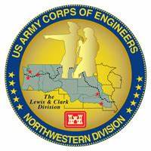
Columbia River System (CRS) Fish Facility Design Review Work Group (FFDRWG)

USACE, Portland District (NWP) and Walla Walla District (NWW)
  - January 2025 Meeting Notes
January 2, 2025

2025 FFDRWG Meeting files:
https://pweb.crohms.org/tmt/documents/FPOM/2010/FFDRWG/CY2025/index.html

FFDRWG contact list - ** notify Chuck and Jake of any changes
BPA
Christine Petersen
Leah Sullivan
Ben Hausmann
Carolina Andes
Josh Ashline
Tammy Mackey
NOAA
Gabriel Brooks
Trevor Conder
Claire McGrath
Kelsey Swieca
Chris Magel
Kinsey Frick
Dana Bethea
USFWS
Dave Swank
Shelby Fowler
Joe Skalicky
States
Erick Van Dyke (ODFW)
Ben Clemens (ODFW)
C. Morrill (WDFW)
Jonathan Ebel (IDFG)
Marika Dobos (IDFG)
CRITFC/Tribes
Tom Lorz (CRITFC)
Laurie Porter (CRITFC)
Greg Silver (CRITFC)
Aaron Jackson (CTUIR)
Ralph Lampman (YN)
Keely MurdocH (YN)
Tod Sween (NPT)
Jay Hesse (NPT)
Lyman Jim (CTWS)
Casey Baldwin (CTCR)
Michael Karnosh (CTGR)
Lawrence Schwabe (CTGR)
Torey Wakeland (CTGR)
NPCC
Kris Homel
FPC
Erin Cooper
Noah Campbell
PSMFC
Gordy Axel
Darren Chase
Roger Clark
Mark Leonard
Scott Livingston
Nicole Tancreto
CENWD
Doug Baus
Tim Dykstra
Dan Feil
Cindy Studebaker
Lisa Wright
Sean Tackley
Ian Chane
CENWP-PM
Ida Royer
Erin Kovalchuk
Mark Bierman
Nathan McClain
Jake Macdonald
Claire Coxen
Marie Adams
Jon Rerecich
David Trachtenbarg
Scott Fielding
*add Courtney Hollins
CENWP-OD
Jeanette Flemmer (BON)
Tucker Gossett (BON)
Jase Owens (BON)
Becca Cates (BON)
Eric Grosvenor (TDA)
Jeff Randall (TDA)
Aaron Young (TDA)
David Miller (JDA)
Michael Lotspeich (JDA)
Laura Rickets (JDA)
Robert Wertheimer (FFU)
Patricia Madson (FFU)
Darren Gallion (FFU)
Kyle Tidwell (FFU)
CENWP-ENC
Aaron Litzenberg (HD)
Shari Dunlop (HD)
Chris Motti (HD)
Steve Schlenker (HD)
Max Wilson-Fey (HD)
Adam White (DE)
Collin Porter (DS)
Dan Penn (DM)
Cole Marfise (DM)
Adam Jones (DG)
*add Nicholas Rillstone (DS)
CENWW-PM
Chuck Barnes
Ryan Ashcraft
Steve Sipe
Ricardo Walker
Brad Trumbo
Liana Aker
Michael Erickson
Karen Zelch
CENWW-OD
Chris Peery
Tiffany Stoeckig-Dixon
Denise Griffith
Elizabeth Holdren
Ken Fone
Bobby Johnson
Deb Snyder
CENWW-ENC
Jon Renholds
Sean Milligan
Ryan Pestes
Travis Foster
John Lomeland
Ryan Laughery

Review Notes from last meeting (emailed by Ryan Ashcraft on 11/13)
https://pweb.crohms.org/tmt/documents/FPOM/2010/FFDRWG/CY2024/index.html

NWW Updates

NWW MNA Turbine Replacement Design – Jean Desjarlais (PM), Jon Renholds (TL)
GE is fabricating adjustable components, arriving Spring/Summer. Unit 14 OOS in September for first replacement. ERDC evaluations to fill gaps in operating range. Meeting this Spring to discuss the operating range. Designing fixed blade runner, 3rd iteration. Testing modified draft tube configuration through August. MCN general model visit in February, may have an opportunity to look at the turbine model at the same time. Charlie would like that.
TL: Oil seal designs checked in light of oil issues at BON? JR: Working it. JF: Will put JR in touch with experts at BON.

NWW IHR Turbine Cooling Water Exclusion - Karen Zelch (PM), Chuck Barnes (Bio)
Gaps around the edges were found and repaired with epoxy.
TL: Was it a measurement issue that caused the gaps? CB: It’s more due to irregularities in the concrete.
TC: Good idea to inspect the new hood after 1 year of operation, don’t wait 3 years. Concerned the epoxy filler could chip away over time. CB: Agrees, should be able to do it with an ROV with the unit watered up.
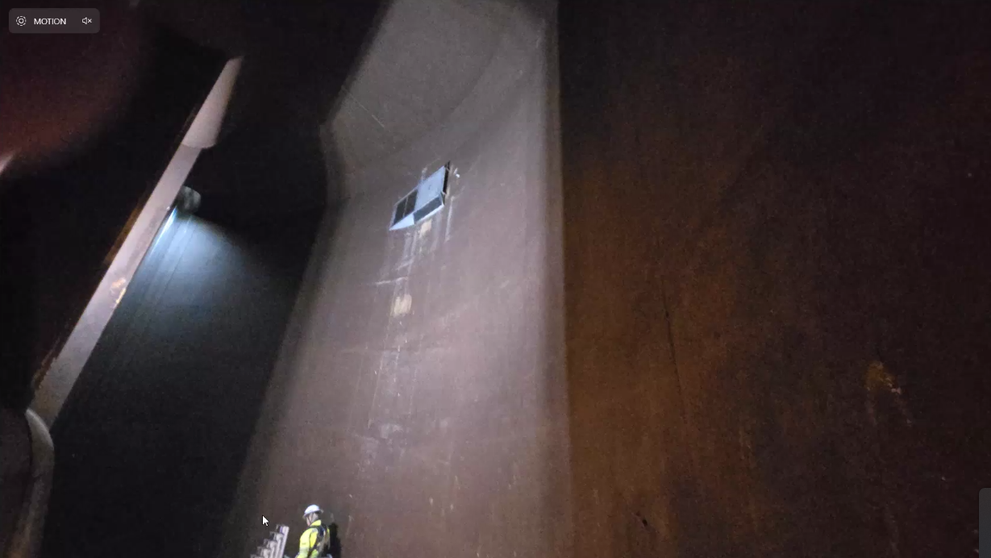
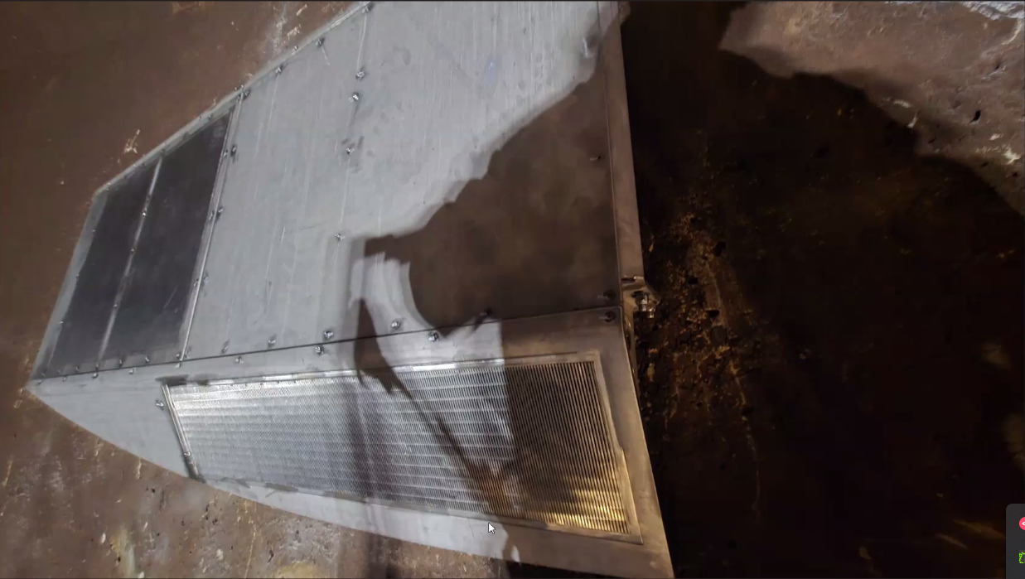

NWW LLA Adult Ladder Turn Pool Gate - Greg Linklater (PM), Chuck Barnes (Bio)

Walleye Passage at Lower Granite Dam – Marika Dobos (IDFG)
See Dobos_2024_WalleyePassageStudyLGR.pdf
ACTION: Chuck will take the information presented to the LLA turn pool gate PDT and brainstorm any ways that project could assist IDFG efforts to slow the movement of walleye into the LGR pool without affecting other species. IDFG is confident we’ll think of something, NOAA is skeptical. Good luck, Chuck...

NWW MCN Avian deterrence – Karen Zelch (PM), Ryan Ashcraft (Bio)
Alternatives workshop was 19-December. FFDRWG review coming soon (next month or so).
TL: Interested in moving this project along.

NWW MNA PIT Detection – Karen Zelch (PM), Chuck Barnes (FFDRWG)
Putting together more detailed descriptions of the alternatives. Review meeting with FFDRWG in the next month or so.

NWW John Day Dam and Snake River Ladder Cooling – Karen Zelch (PM), Ryan Ashcraft (FFDRWG)
Site visits on Dec. 10-11. Contractor still getting spun up. FFDRWG review coming soon. Revised version of LGR alternatives matrix.

NWP Updates

NWP TDA Backup AWS debris management – Marie Adams (PM), Mehdi Roshani (TL), Jon Rerecich (FFDRWG)
50% submittal for the TDA AWS Backup Debris Management project sent for FFDRWG review on 12/23, comments due 1/17.

NWP BON Spillway rock mitigation – Marie Adams (PM), Adam Jones (TL), Scott Fielding (FFDRWG)
Technical review right now, then on hold awaiting construction funding.
TL: confirm that this project is on the SCT sheet.

NWP BON1 lamprey passage improvements – Erin Kovalchuk (PM), Adam White (TL), Jake Macdonald (FFDRWG)

NWP BON2 control section redesign – Erin Kovalchuk (PM), Adam White (TL), Jake Macdonald (FFDRWG)
PM unable to attend today. Construction update and further discussion over March operation alternatives will be provided at next week’s FPOM.

Exit channel PIT detection for post-construction evaluation – Tom Lorz (CRITFC). See Ref_A_SOW_Washington Shore PIT.pdf, NMFS proposed scope of work.
“Wagon wheel” antenna proposed by NMFS is not popular with the Region. Gabriel Brooks (NMFS) will talk with PSMFC next week and will be physically in Tri-Cities the week of February 10th to discuss alternatives to the wagon wheel. Some ideas already thrown around include a fin style antenna in place of the wagon wheel and splitting the bulkhead slot antenna into two halves to eliminate the need for a second antenna altogether. More to come…

NWP TDA lamprey passage improvements – Erin Kovalchuk/Courtney Hollins (PM), Adam White/Nicholas Rillstone (TL), Jake Macdonald (FFDRWG)
PM unable to attend today. Updates on holding tank capacity upgrade (Grosvenor) and volitional passage design kickoff (Hollins) will be provided at next week’s FPOM.
ACTION: Jake will add new members Courtney Hollins (PM) and Nicholas Rillstone (TL) to the FFDRWG.

NWP JDA lamprey passage improvements – Erin Kovalchuk/Courtney Hollins (PM), Adam White/Nicholas Rillstone (TL), Jake Macdonald (FFDRWG)
PM unable to attend today. Updates on LPS water supply repairs (Lotspeich) and volitional passage design kickoff (Hollins) will be provided at next week’s FPOM.

NWP BON1 PIT Detection – Mark Bierman (PM), Jeanette Flemmer (FFDRWG)
Construction update will be provided at next week’s FPOM.

NWP prototype floating adult lamprey collector for tribal translocation, aka. “FALCON” (*partner project; not a USACE design) – Ralph Lampman (TL), Jake Macdonald (FFDRWG)

Trevor Conder (NOAA Fisheries) filed a memo on 5/13/2015 recommending that lamprey openings in FCRPS fish ladders be limited to 1.5 inches or less. See Memo_Salmon_Interaction_Lamprey_Orifice.docx.

CRITFC member tribes sent a memo on 11/3/2024 requesting NOAA Fisheries revisit the limit established in 2015 for certain applications that were not being contemplated in 2015. See Memorandum regarding Pacific Lamprey standard maximum opening size.docx.

Trevor Conder (NOAA Fisheries) responded via email on 12/11/2024: “I am not convinced there is sufficient evidence in this memo or elsewhere at this point for NOAA to back off the 1.5-inch max opening within the fish ladder. We are willing to test other dimensions outside of the ladder within the BRZ with sufficient monitoring. That would include additional space above 1.5 inches for the millennium falcon, but I don't think anyone wants to exceed 12 parsecs.”

Ralph Lampman representing the CRITFC member tribes, and Trevor Conder representing NOAA Fisheries, have agreed to discuss these two memos in the FFDRWG forum and let the work group help with a resolution and a path forward for the FALCON experiment in 2025.
NOAA won’t move from 1.5 inches within the fishways until a more robust study produces compelling evidence that larger lamprey openings don’t delay salmon passage.
Previous studies were inconsistent with their definitions of ‘interactions’, making them difficult to interpret.
NOAA is open to experimenting with larger openings outside of the fishways (in the tailrace or forebay) with monitoring for negative interactions.
The new Washington Shore control section will have 1.5 inch lamprey orifices and full-size salmon orifices, both outfitted with PIT antennas. Our post construction evaluation may give us some insight into the size of opening lamprey prefer.
Lampman proposed a deployment method for the FALCON at November FFDRWG using a dual rail system and trolleys. This method would position the FALCON with one end against a wall. Last year’s experiments suggested this is the best configuration.
JM: There are two I-beam rails near the Washington Shore North downstream entrance that look similar to the rails in Ralph’s sketch. If those rails are in good condition, perhaps CRITFC/Tribes could use them for FALCON? JF: Heard from Ricky that those rails are in poor condition and may not be usable. ACTION: Jake/Jeanette/Becca will follow up on the condition of the I-beam rails at Washington Shore and determine if they are usable or not.
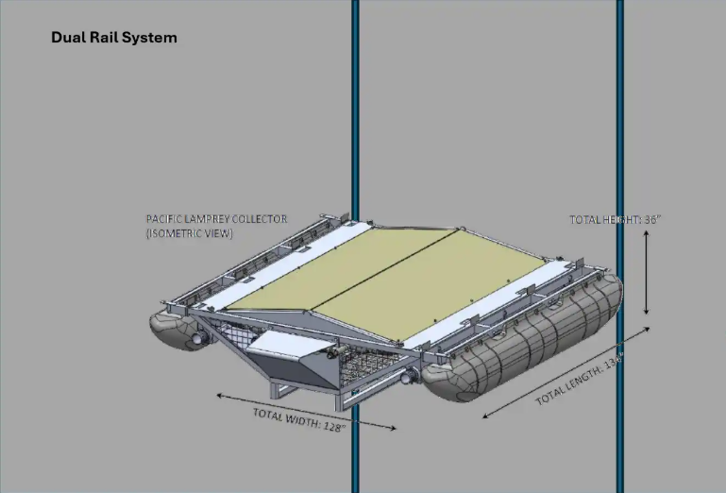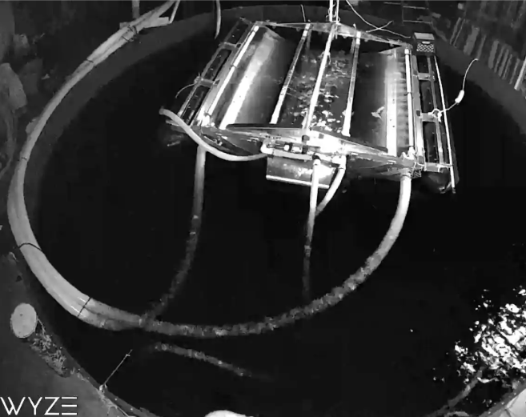
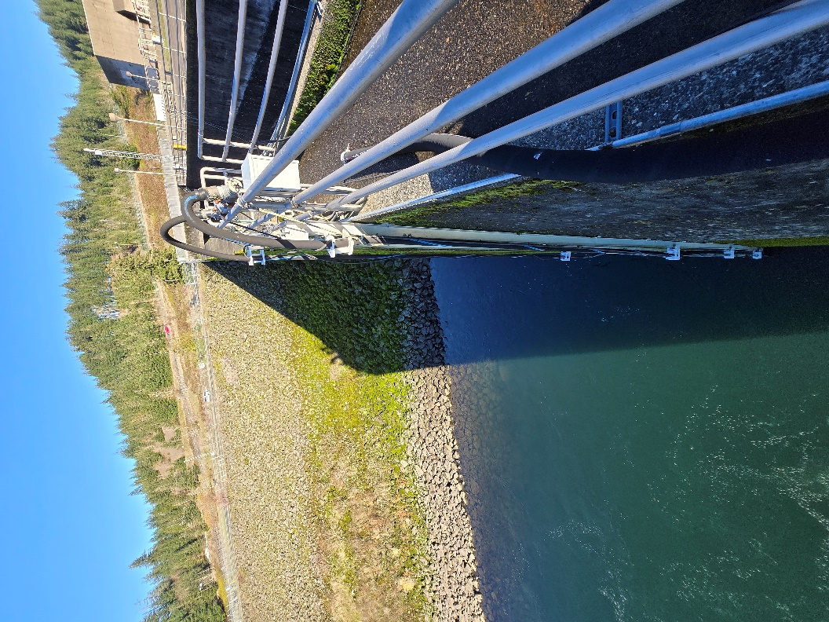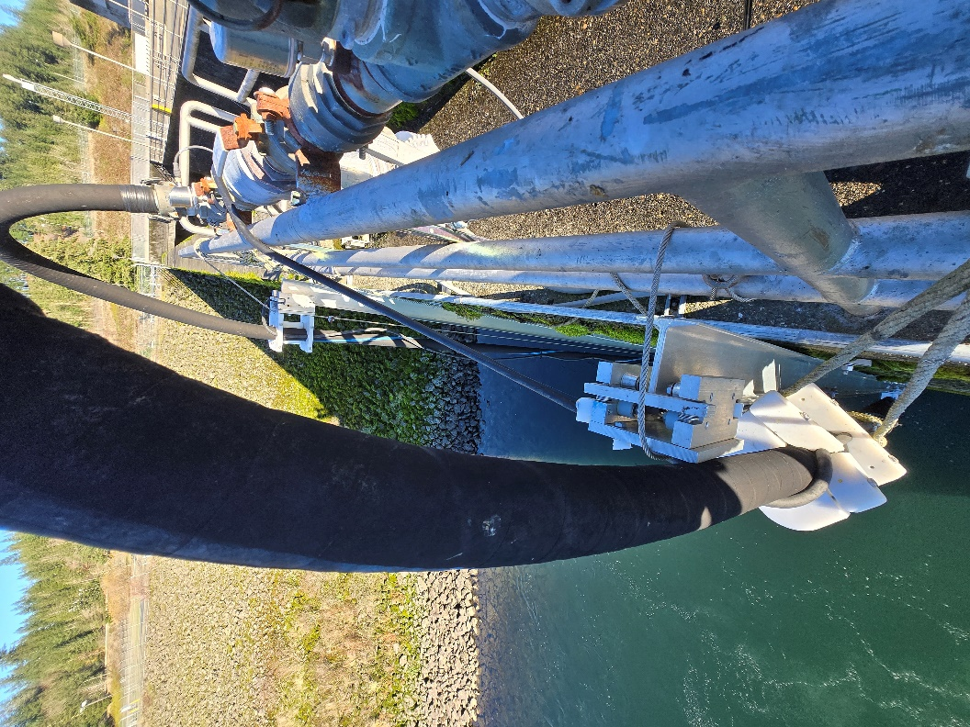

Upcoming meetings and field trips

Next regularly scheduled NWW/NWP FFDRWG meeting – Thursday, February 6th @ 09:00

January FFDRWG Field Trips:

Bonneville Washington Shore Control Section – set a date.
ACTION: Jake will try to coordinate a site visit for Thursday January 30th

SRWG FY 2026 AFEP Planning Cycle:

FY26 AFEP planning cycle kickoff meeting – Friday 2/14/25. Location: TBD

FY26 AFEP research summary review and development meeting – Thursday 3/6/25. Location: TBD

FY26 AFEP research summary scoring meeting – Friday 5/2/25. Location: TBD

FY26 preliminary proposal review meeting – Thursday 7/3/25. Location: TBD

FY26 AFEP final proposal review meeting – Friday 8/29/25. Location: TBD

